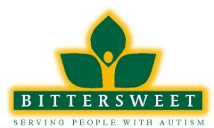
Recruiting Specialist
Bittersweet Farms is a world renowned leader in serving individuals with autism. We are seeking candidates for a full-time Recruiting Specialist. This position will coordinate the internal job posting process, conduct outside recruitment of qualified candidates to fill all non-exempt positions, place recruitment ads, conduct phone interviews, and coordinate interviews with hiring managers, lead bi-weekly staffing meetings, and analyze recruitment data to present at each meeting. The Recruiting & Training Specialist will also be responsible for the implementation of staff development including coordination, scheduling and conducting training classes, retreats, in-services and education for newly hired staff, current staff and supervisors.
The right person will possess high energy with a sense of urgency in responding to organizational needs. Also, this position requires exceptional interpersonal, organization and phone skills. Qualified candidates must have excellent computer skills, including the use of Word, Excel, Outlook, and prior HRIS experience. A Bachelor's Degree preferably in Human Resources is desired but extensive recruitment or training experience will be considered in lieu of a degree.
Please visit our website at www.bittersweetfarms.org to learn more about us and complete an application. You may also fax your resume to 419-875-5593 or mail to: Bittersweet, Inc, 12660 Archbold Whitehouse Road, Whitehouse, OH 43571

